Lesson 5 – CSS Separation, Style replication prevention & Positioning

CSS Seperation & Structuring your files & folders
There are 3 ways to write CSS:

- Inline
<div style=”background: #FF0000; color:#FFFFFF;”>Hello World</div>
- In style tags which should be in your head of your html page but can be placed anywhere but DO NOT do that.
- And in a separate file using the link tag in the html head (this is the best way)

The link tag
This is how you would link a css file, with a html file.

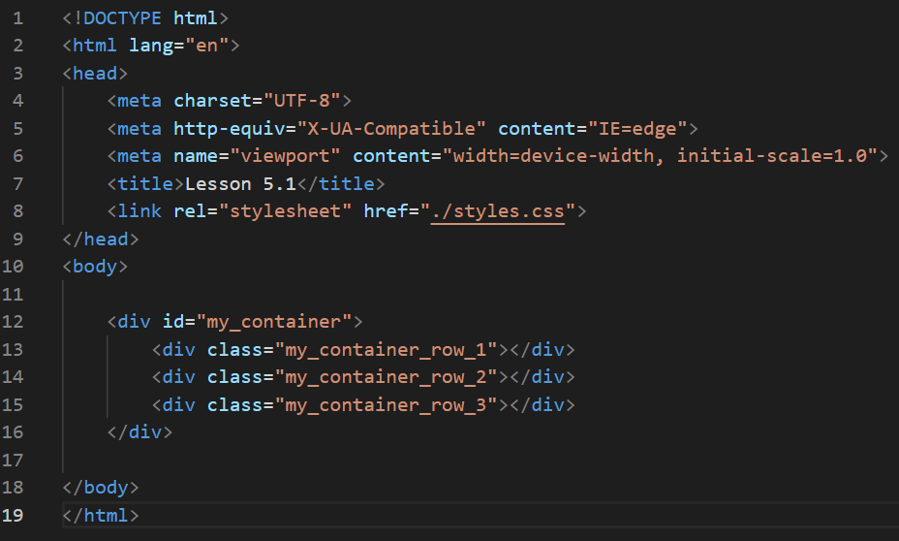

IMPORTANT: Now when your creating your own tests and examples, you should make an empty folder to work in to keep things clean and easy to work with.

So from the above you will have 1 html file and 1 css file called styles.css, see lesson 5 example-1 folder.
Urls, files, relative and absolute
Do not get URL’s mixed with file paths. What’s the difference you may ask?

https://aftc.io/ is the root of the domain aftc.io

/ is the root when linking to a file in a html file

./ is the relative path to where the html file is.

IMPORTANT: Now you can use web links to link to css and javascript files but they then wouldn’t work when your working on your computer. You will find you make a change and the change doesn’t appear as you will be loading the online version of that file rather than the one on your computer. So you should always use / or ./

An absolute path starts with a / or a full url (web address)
A relative path starts with ./

Structure and file organisation is VERY important
Please see lesson 5 example 2 folder and see the folders I have created and how they are used.

Note that the path (not URL) to the CSS file and the image are RELATIVE, not absolute. So they find the css and image file from where the html file is placed. If you used an absolute path / you would have to ensure it find the file from root location on your computers harddrive. For a web server an asbolute path would be the domain name / would take you to the root eg https://aftc.io/

So if you had a web server on your computer like I do, then I can use / and know it would work on the website as I set my projects up to work like this but as your going to be creating ebooks I would make a guess and recommend you use relative file paths ./

Also take note that on the folders:

- assets folder – for assets such as video, sound, images etc
- assets/images folder – for images
- includes folder – for includes such as css, javascript and fonts
- includes/css – for css includes
- includes/js – for javascript includes
- includes/fonts – font font file includes (could go in assets but usually it’s in includes)

IMPORTANT: This is a very common structure, I suggest you ALWAYS create your projects with this setup - See lesson 5 example 2 folder.

The prevention of CSS style duplication, 1 style to rule them all
Please see lesson 5 example 3 folder.

Now we have DIV 3 rows and they all share a common height, but I don’t want to write the same height for each of them, wasting CSS programming (this is a small example but it could be 100s of lines of CSS in more complicated projects), so what do we do?

Here’s the HTML

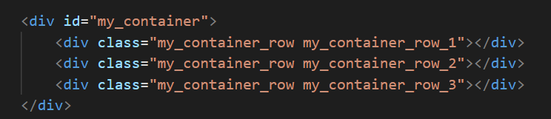
Note that I’ve added 2 css styles, each div inside the ID has a common css class called my_container_row, if you check the css file in the previous examples 1 & 2 that the height is specified for each row, now we can add that 1 class and customise all rows with those styles.

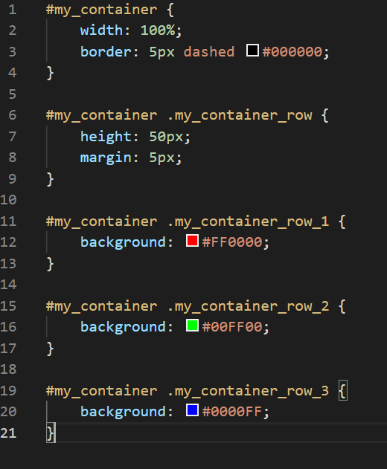
CSS Positioning and the issues with containers keeping their size
Now take a look at lesson 5 example 4.

If you have noticed on each of the examples I’ve been placing a border around the root css element / the root css container / the root html container (the element with the ID).

There’s a reason for this and here it is… Notice now that the height of my_container is virtually flat.

This is because all content in them is using POSITION ABSOLUTE, html containers / elements are unable to work out the height of a container when they are in this mode, so you have to either set it manually or structure you page content so that you fit your html objects or even animations within a certain area. It becomes a lot lot more complicated when you have an animation that is the length of a scrolling page, the container (root element with ID), could be 1000s of pixels in height to achieve this.

The HTML stacking structure
In HTML nearly all HTML tags (p, div etc), without styling are stacked on top of each other. So when you write a HTML page with no styles (which you should always do first). Most things will be stacked upon each other like paragraphs in a page from a book, but not all html tags will do this.

Tags that will stack are: div, p, button etc
Tags that wont stack are: span, label etc

To control how this behaves there are CSS properties such as DISPLAY & POSITION which can alter this behaviour. But you need to plan the structure of your page if you start to play with the stacking of HTML elements. The most common way to do this is to keep the stacking, but you have a container which you specify a height for and then you position things using the CSS command POSITION: ABSOLUTE inside it. NOTE: The container must have POSITION: RELATIVE for this to work correctly. This is going to play a big part in animation in further lessons. But for now, it’s something I want you to be aware of.

Lesson 4 was mostly about colours but you should have noticed that the DIV tags stacked everything in rows.

Tests

Test 1.
I want you to duplicate lesson 5.4 folder call it test-01 in your lesson 5 folder, and make the root container the correct height sp that the 2 boxes fit correct. I expect a url like https://dan.aftc.io/lesson-05/test-01/index.html

NOTE: you wont need to add index.html to an url links as index.html is automatically looked for by web servers. So your test should be at https://dan.aftc.io/lesson-05/test-01

Do this for the naming of all other tests also.

NOTE: The reason behind doing this is to preserve the HTML stacking structure, if you add HTML elements below they will start from the container (which is why I put a border on example 5.4 for you, so that you can see that it is flat)

Test 2.
I want you to duplicate lesson 5.4 folder call it test-02, now I want you to add 2 more boxes, 1 at the bottom left of the container (choose a reasonable height for the container) and 1 at the bottom right of the container. Box 1, should be some shade of red, box 2 should be some shade of green, box 3 should be some shade of blue, box 4 should be any random colour you want but with its opacity or alpha set to 0.5.

Test 3.
I want you to duplicate test-02 folder call it test-03, now I want you to make the box container fit the whole of the web browser. HINT: Position fixed.

Test 4 – Challenge 1
I want you to duplicate test-03 folder call it test-04, now if you done test 3 correctly, you will notice things are slightly out of the screen. Fix that. HINT: Style the body tag.

Test 5 – Challenge 2
I want you to duplicate test-04 folder call it test-05, now I want you to make 3 containers with a box in each corner using absolute positioning.

HINT 1: CSS IDs are for single use only
HINT 2: Your going to need to set the height
HINT 3: Its more about code duplication in the html and just tweaking the styles.

